# HERMES: High-speed Event Retrieval and Management for Enhanced Spectral neutron imaging with TPX3Cams

HERMES Manual! Everybody cheer!

Version 8.4.2025

Table of Contents

HERMES: High-speed Event Retrieval and Management for Enhanced Spectral neutron imaging with TPX3Cams 1

1. Overview 2

2. Installation 3

2.1 Linux/MacOS Instructions 3

3. Data Acquisition 4

3.1 System Overview 4

3.2 Directory Structure 4

3.3 Configuration File 5

3.4 Command Line Interface (CLI) 6

3.4.1 Default Behavior 6

3.4.2 CLI Flags 7

3.4.3 Verbosity Levels 7

3.4.4 Dry Run Mode 8

3.5 Examples 8

3.6 Acquisition Process Flow 8

4. Unpacking Data 9

4.1 Create Unpacker 9

4.2 Unpacker Command Line Interface 9

4.2.1 Using the CLI 9

4.2.2 Unpacker Configuration File 10

4.2.3 .rawSignals Structure 12

4.2.4 Examples 12

5. Analyzing Data with HERMES packages 13

5.1 loader.py 14

5.1.1 Load Function 14

5.1.2 Exporter Functions 15

5.2 plotter.py 15

5.3 analyze.py 15

5.3.1 Summary/Diagnostic Functions 16

5.3.2 Filtering Functions 16

5.4 Coding Examples 16

5.4.1 Loader Examples 16

5.4.2 Plotter Examples 18

5.4.3 Analyzer Examples 18

5.5 Example Notebook Files 18

# Overview

HERMES comprises a set of Python and C/C++ libraries (not a standalone program) designed to support the development of custom code for acquiring, processing, and analyzing data from the TPX3Cam manufactured by [Amsterdam Scientific Instruments](https://amscins.com/resources/technology/). HERMES' primary function is providing the foundational tools needed for users to create applications tailored to their specific requirements in energy-resolved neutron imaging with TPX3Cams, along with its subsequent analysis. With HERMES users have access to a flexible framework that simplifies the integration of TPX3Cam's capabilities into their projects, while also providing the needed diagnostics for development and trouble shooting.

HERMES has three primary functions:

1. Acquire

Easily connect to TPX3Cams and simplify the data acquisition process.

1. Unpack

Unpack the .tpx3 binary files from acquisition and unpack into a .rawSignals file.

1. Analyze

Provide basic data analysis tools for users of TPX3 camera systems.

# Installation

To install HERMES, you need to install both the HERMES directory from GitHub and pixi. Currently, HERMES is not supported by Windows, only Linux/MacOS systems. HERMES has been shown to work on WSL environments.

## 2.1 Linux/MacOS Instructions

Run the following code in order:

curl -fsSL https://pixi.sh/install.sh | sh

git clone https://github.com/lanl/HERMES.git

Now, cd into your HERMES directory that was just created:

user@hostname:~/HERMES

Run:

pixi install

pixi shell

pixi run build-cpp

Pixi will automatically install required dependencies and manage the python version for HERMES. If everything worked correctly, you should see the text (hermes) in your terminal preceding the current address:

(hermes) user@hostname:~/HERMES

From here, HERMES has successfully been installed. To get started, run the following code in your base HERMES directory (/HERMES)

cp examples/notebooks/analysis_hermes workspace/

This provides a basic starting point for HERMES users. See section 5 for using this example file.

# Data Acquisition

## System Overview

The acquisition scripts interface with the TPX3Cam and SPIDR readout boards using the tpx3serval Python file. These scripts can configure the camera, setting up run directories, logging configuration files, and performing one or more acquisition runs.

To acquire data, the TPX3Cam must already by running and connected to Serval. Serval is a program that connects a TPX3Cam to a computer using a local server. To operate different camera procedures, an operator must direct the server to different addresses. This step is annoying to perform manually, so HERMES performs these operations instead. For more information view the Serval manual.

## Directory Structure

HERMES has a structured directory layout. The working directory contains one folder for each run and several subfolders for specific data files.

The acquireTpx3.py script will automatically generate these folders if they do not already exist.

## Configuration File

The acquire_config.ini file defines all configurable parameters for acquisition.

**Sections and Parameters:**

• **[WorkingDir]**

* path_to_working_dir: Full path to working directory (required)
* path_to_init_files: Path for initialization files
* path_to_status_files: Path for status files
* path_to_log_files: Path for log files
* path_to_image_files: Path for image files
* path_to_preview_files: Path for preview files
* path_to_rawSignal_files: Path for .rawSignals files
* path_to_raw_files: Path for raw .tpx3 files

**• [ServerConfig]**

* serverurl: URL for TPX3Cam server (default: http://localhost:8080)
* path_to_server: Path to the Serval directory
* path_to_server_config_files: Path to camera settings directory
* bpc_file_name: Pixel configuration filename
* dac_file_name: DAC configuration filename
* destinations_file_name: Server destinations file
* detector_config_file_name: Detector configuration file

• **[RunSettings]**

* run_name: Name for the run (used as folder name and in filenames)
* run_number: Starting run number (default: 0000)
* trigger_period_in_seconds: Camera trigger period
* exposure_time_in_seconds: Exposure time (must be ≤ trigger period)
* trigger_delay_in_seconds: Delay before triggers
* number_of_triggers: Number of triggers per run
* number_of_runs: Total number of runs to perform
* global_timestamp_interval_in_seconds: Timestamp interval

## 3.4 Command Line Interface (CLI)

### 3.4.1 Default Behavior

The CLI provides a flexible way to run acquisitions. Defaults are built into the script; a configuration file and/or CLI flags can override these defaults.

Usage:

In the same directory as the acquireTpx3.py script, run:

python acquireTpx3.py [options]

By default, no configuration file is required. If using defaults, file/folder locations will still need to be changed. Configuration options can be provided via:

* 1. Config file (-c or --config)
  2. CLI flags (highest precedence)

**Default Behavior (no config):**

* Trigger period: 10 s
* Exposure time: 9 s
* Number of runs: 1

### 3.4.2 CLI Flags

**General Options**

* -h, --help: Information on available commands
* -c, --config: Path to config file
* -W, --working-dir: Working directory path
* -r, --run-name: Run name (folder name and filename prefix)
* -N, --run-number: Starting run number (integer, zero-padded as 0000)
* -n, --num-runs: Total number of runs
* -t, --trigger-period: Trigger period (s)
* -e, --exposure: Exposure time (s)
* -T, --num-triggers: Number of triggers per run
* -v, --verbose: Verbosity
* --dry-run: Print effective configuration and exit

If the help command is ran, the following output will be placed in the terminal:

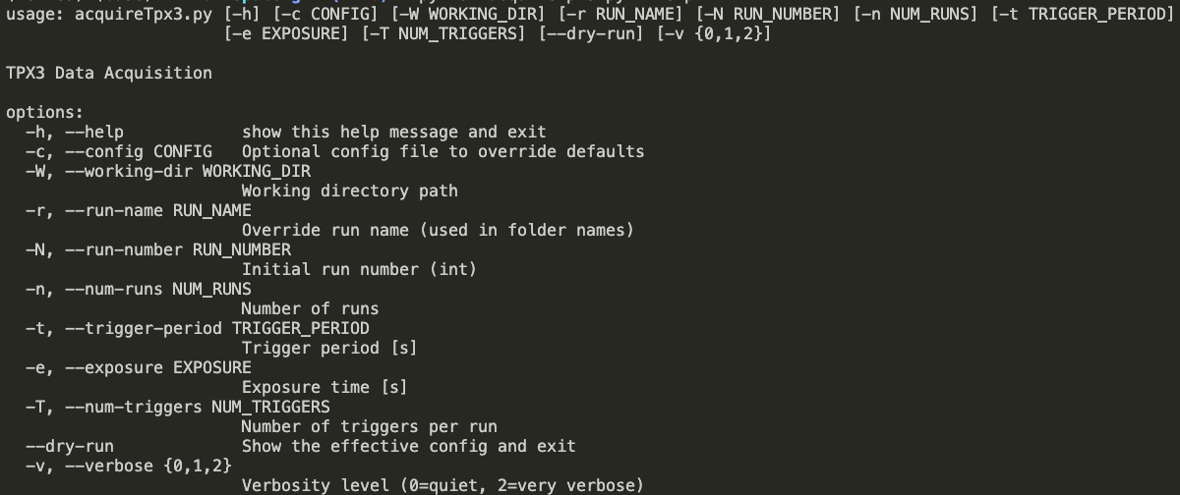

### 3.4.3 Verbosity Levels

• **0 (quiet):** Only errors printed

• **1 (info):** Standard information messages (default)

• **2 (debug):** Full configuration printouts and detailed logs

### 3.4.4 Dry Run Mode

Use --dry-run to preview the final merged configuration (defaults + config + CLI flags) without running any acquisition.

## 3.5 Examples

Use defaults and specify working directory:

python acquireTpx3.py -W /data/acquisition_test

Load a config file and override exposure time

python acquireTpx3.py -c acquire_config.ini -e 5

Specify working directory, run name, and number of runs

python acquireTpx3.py -W /data/beam_test -r beam 2025 -n 10

Load config file and override multiple parameters

python acquireTpx3.py -c acquire_config.ini -e 7 -t 12 -T 25

Full example with almost all parameters

python acquireTpx3.py -c acquire_config.ini -W /data/full_test -r complex_run -N 5 -n 8 -t 15 -e 12 -T 30 -v 2

## 3.6 Acquisition Process Flow

**To acquire data, the TPX3Cam goes through 4 steps:**

1. **Configuration:** Script merges defaults, config file, and CLI flags.
2. **Directory Verification:** Working directory and run folder are created or cleaned.
3. **Camera Check:** TPX3Cam connection is verified.
4. **Run Execution:**
   * Run number is incremented and formatted.
   * Configuration files and detector status are logged.
   * Exposure is started using the configured parameters.
   * Data is written into the appropriate subdirectories.

For details on TPX3Cam server and dashboard behavior, refer to the **Serval Camera Manual**.

# 4. Unpacking Data

Unpacking data in HERMES requires use of C++ files to turn .tpx3 files into .rawSignals files.

## 4.1 Create Unpacker

In a terminal, navigate to your HERMES directory. This should be the directory that contains folders such as src, workspace, and examples. In this directory, run:

cd src/chermes && make && cp unpacker.config ../../workspace/ && cp bin/tpx3SpidrUnpacker ../../workspace/ && cd ../../

This will create the binary file to run the unpacker and copy it into the workspace area, along with a default configuration file. If you try to run this command multiple times, you may get the error:

make: Nothing to be done for 'all'.

In this case, navigate to /src/chermes/bin and delete tpx3SpidrUnpacker. Re-run the code and everything should work.

## 4.2 Unpacker Command Line Interface

### 4.2.1 Using the CLI

To run and test the unpacker, navigate to workspace. The HERMES unpacker utilizes a command line interface format to unpack data files from a location. You can view a help menu by inputting:

tpx3SpidrUnpacker OR tpx3SpidrUnpacker -h OR tpx3SpidrUnpacker --help

The following options are available for unpacking:

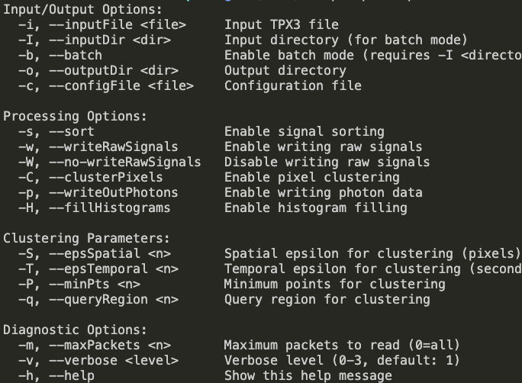

### 4.2.2 Unpacker Configuration File

Like HERMES acquisition, all these parameters can also be specified in a configuration file. The template for the unpacker configuration file is given in unpacker.config, which was automatically copied into the workspace alongside the binary file.

The default configuration file appears as so:

A clustering function is built into the unpacker of HERMES; however, many users may desire to cluster using custom parameters or functions, thus allowing for clusterPixels to be enabled or disabled. Below are definitions for each customization option:

rawTPX3Folder = The path to your .tpx3 directory that you want to unpack.

rawTPX3File = The filename of a specific .tpx3 file you want to unpack. Set to ‘ALL’ for batch mode, unpacking every file in rawTPX3Folder.

outputFolder = The path to your .rawSignalFiles directory that you want unpacked files to be saved in.

writeRawSignals = Enable/Disable ability to write raw signals

sortSignals = Enable/Disable ability to sort signals

fillHistograms = Enable/Disable ability to fill histograms (*I think this is outdated and needs to be removed).

clusterPixels = Enable/Disable ability to cluster pixel hits.

writeOutPhotons = I have no idea what this does.

verboseLevel = Gives user detailed terminal output depending on value. 0 = Silent mode, 1 = Basic Information, 2 = Detailed logs

maxPacketsToRead = Maximum number of packets to read. 1 packet is 64 bits, or generally is one ‘event’, whether that be a TDC, pixel hit, GTS, or control signal. Set to 0 to unpack all packets.

### 4.2.3 .rawSignals Structure

The HERMES unpacker saves unpacked files as .rawSignals files, which contain the following structure:

This structure is further unpacked into an array with basic processing. See section 5.3 for HERMES functions to analyze .rawSignals files.

Generally, useful data will have a signalType of 1, 2, or 3. A signalType of 4 or 5 shows a SPIDR Control signal and TPX3 Control signal respectively, and any other signalType value is not useful and can be discarded. We are in the process of refining this unpacking to produce less useless information and retain a more memory-efficient system.

### 4.2.4 Examples

Unpack a single .tpx3 file with default settings:

tpx3SpidrUnpacker -i data/run0001.tpx3 -o output/

Unpack a single .tpx3 file with a configuration file:

tpx3SpidrUnpacker -i data/run0001.tpx3 -o output/ -c unpacker.config

Process an entire directory in batch mode:

tpx3SpidrUnpacker -I data/ -b -o output/

Unpack and cluster pixels with custom parameters:

tpx3SpidrUnpacker -i data/run0002.tpx3 -o output/ -C -S 2 -T 5e-9 -P 3

Unpack using most available options:

tpx3SpidrUnpacker -I data/runs/ -b -o output/full_test/ -c -unpacker.config -s -w -p -H -C -S 3 -T 1e-8 -P 5 -q 10 -m 50000 -v 2

# 5. Analyzing Data with HERMES packages

HERMES offers a handful of features to allow for data analysis of .rawSignals, .csv, or .pixelActivations files. These files are acquired from different sources:

|  |  |  |
| --- | --- | --- |
| Program | Executable | Output File Extension |
| HERMES | .tpx3 | .rawSignals |
| EMPIR |  | .pixelActivations |

HERMES has several built-in packages that allow for quick and easy data analysis. These packages are in the src/hermes/analysis folder. To use these packages, include the following headers as part of your imports:

from hermes.analysis.loader import SignalsIO

from hermes.analysis.plotter import BufferPlotter, HistogramPlotter, ToAImageSequenceGenerator

from hermes.analysis.analyzer import SignalAnalyzer

Note that any changes made to a package file will only be implemented if the kernel is restarted to load the package once again. Below are all the packages currently implemented into HERMES and the abilities their functions provide.

## 5.1 loader.py

This module provides functionality to load various file types (.rawSignals, .csv, .pixelActivations) and convert them into pandas DataFrames. The loader also can export these same pandas DataFrames into .csv and .parquet files. Together, the loader.py module provides three functions for users to utilize in their analysis.

### 5.1.1 Load Function

The load function is a powerful tool to easily load individual files or a folder of files into a pandas DataFrame. At its minimum, the load function only requires a path to either a single file or a folder. The base case looks like this:

df = loader.load_data("path/to/file/or/folder")

The loader can automatically detect the extension of the files you are using and load them with their according structure. Once loaded, all files are concatenated into a single DataFrame with the following structure:

|  |  |  |  |  |  |  |  |
| --- | --- | --- | --- | --- | --- | --- | --- |
| bufferNumber | signalType | xPixel | yPixel | ToaFinal | TotFinal | groupId | signalTypeDescription |
| uint16 | uint8 | uint8 | uint8 | float64 | float32 | uint16 | category |

Each row, or 'packet', is equivalent to a single event taken on a TPX3 camera. There will be as may rows as there are packets.

The load function allows for many other parameters besides a path. Below are other parameters and a description:

* format : str - Format of the file to read. Required if multiple valid filetypes in a folder.
* index : str - Index of files to read in folder. Can include start, stop, and step separated by a colon.
* time_adjust : Boolean - Enable ToA continuity across files by adding offset to ToA based on index. Note: If using time_adjust and an index step, the time ToA data will have 'gaps' where a file was skipped over.
* round_period_to : float - Helps time_adjust round to a certain window. Default of 0.5 s.
* file_duration : float - If defined, time_adjust does not assume/round offset and uses a constant duration for offset instead.

See examples in 5.4 for proper usage/syntax.

### 5.1.2 Exporter Functions

HERMES has two basic functions to export a pandas DataFrame to either a .csv file or a .parquet file. Both functions are very simple and require a DataFrame and a string path to save the file. Here is an example of each of these exporter functions:

reader.export_to_csv(df, "path/to/save/data.csv")

reader.export_to_parquet(df, "path/to/save/data.parquet")

If only a filename is provided instead of a full path, the file will save in the same directory as the python file where the function was called. Generally, this would be the workspace.

## 5.2 plotter.py

This module has various plotting functions, yet they are out of date and will be adjusted and documented some time in the near future.

## 5.3 analyze.py

This module contains basic functions for users to perform basic data analysis. This module is the simplest and least refined module of HERMES analysis tools because much analysis requires specialized tools or niche applications. These tools included are meant to be as useful as possible.

### 5.3.1 Summary/Diagnostic Functions

This module contains one summary function that prints basic information about the laoded DataFrame. To call this function, run:

analyzer.get_summary_stats(df, rows=#)

rows is how many rows you would like to preview. The default value for rows is 10. This function will print out how many signals were loaded, the columns of the DataFrame, the distribution of signal types, the time and pixel range, the number of buffers and groups, and a preview of the first few rows.

### 5.3.2 Filtering Functions

HERMES has built-in functions to filter by a specific signalType or a time range.

For filter_by_signal_type, you need a DataFrame and a string signalType of 'TDC', 'Pixel', 'GTS', 'TPX3_Control', or 'SPIDR_Control'.

For filter_by_time_range, you need a DataFrame, a float startTime and a float endTime. Both times must be in seconds. See examples for implementation of both.

With this filtering, you can then use some of the functions in plotter.py to visualize data.

## 5.4 Coding Examples

### 5.4.1 Loader Examples

Setting various paths to different data:

rawSignals_dir = "PATH/TO/YOUR/RAWSIGNALS/DATA"

csv_dir = "PATH/TO/YOUR/CSV/DATA"

pixelActivations_dir = "PATH/TO/YOUR/PIXELACTIVATIONS/DATA"

Load SignalsIO() class into object:

loader = SignalsIO()

Load a single .rawSignals, .csv, and .pixelActivations file:

df1 = loader.load_data("path/to/data.rawSignals")

df2 = loader.load_data("path/to/data.csv")

df3 = loader.load_data("path/to/data.pixelActivations")

Load the .rawSignals files form a folder that has many different file types:

df = loader.load_data("path/to/mixed/data", format="rawSignals")

Load the .csv files from a folder with many file types and only load files 5 through 9:

df = loader.load_data("path/to/mixed/data", format="csv", index="5:10")

Load the .pixelActivations files from directory, load files 10 through 19 with a step of 2, and enable ToA continuity:

df = loader.load_data(pixelActivations_dir, index="10:20:2", time_adjust=True)

Load .rawSignals files from directory, load files 10 through 100 with a step of 5, enable ToA continuity with rounding estimation:

df = loader.load_data(rawSignals_dir, index="10:101:5", time_adjust=True, round_period_to=0.25)

Load .rawSignals files from directory, load files 10 through 100 with a step of 5, enable ToA continuity with defined file duration:

df = loader.load_data(rawSignals_dir, index="10:101:5", time_adjust=True, file_duration=2.5)

### 5.4.2 Plotter Examples

### 5.4.3 Analyzer Examples

Load SignalAnalyzer() class into object:

analyzer = SignalAnalyzer()

Get summary of data that has been loaded:

analyzer.get_summary_stats(df)

Filter DataFrame to only show pixels:

pixel_df = analyzer.filter_by_signal_type(df, "Pixel")

Filter DataFrame to be between time window of 1.5 and 2 seconds:

time_df = analyzer.filter_by_time_range(df, 1.5, 2.0)

## 5.5 Example Notebook Files

HERMES contains an example notebook with many of the function shown above in the file analysis_hermes.ipynb. This file is laid out in a way that is intended to be as easy as possible to get started with. It is recommended to use the extension 'Data Wrangler' to easily visualize data in a Jupyter notebook.